

**UNITY GAME TEMPLATE MONSTER DEFENDER**

USER GUIDE



Table of Contents

I. INTRODUCTION 3

II. PACKAGES 4

III. TEMPLATE CUSTOMIZATION 5

1. Ingame Manager 5

2. Tank Controller 5

3. Enemy Controller 6

4. Boss Controller 7

5. Level Configs 8

# INTRODUCTION

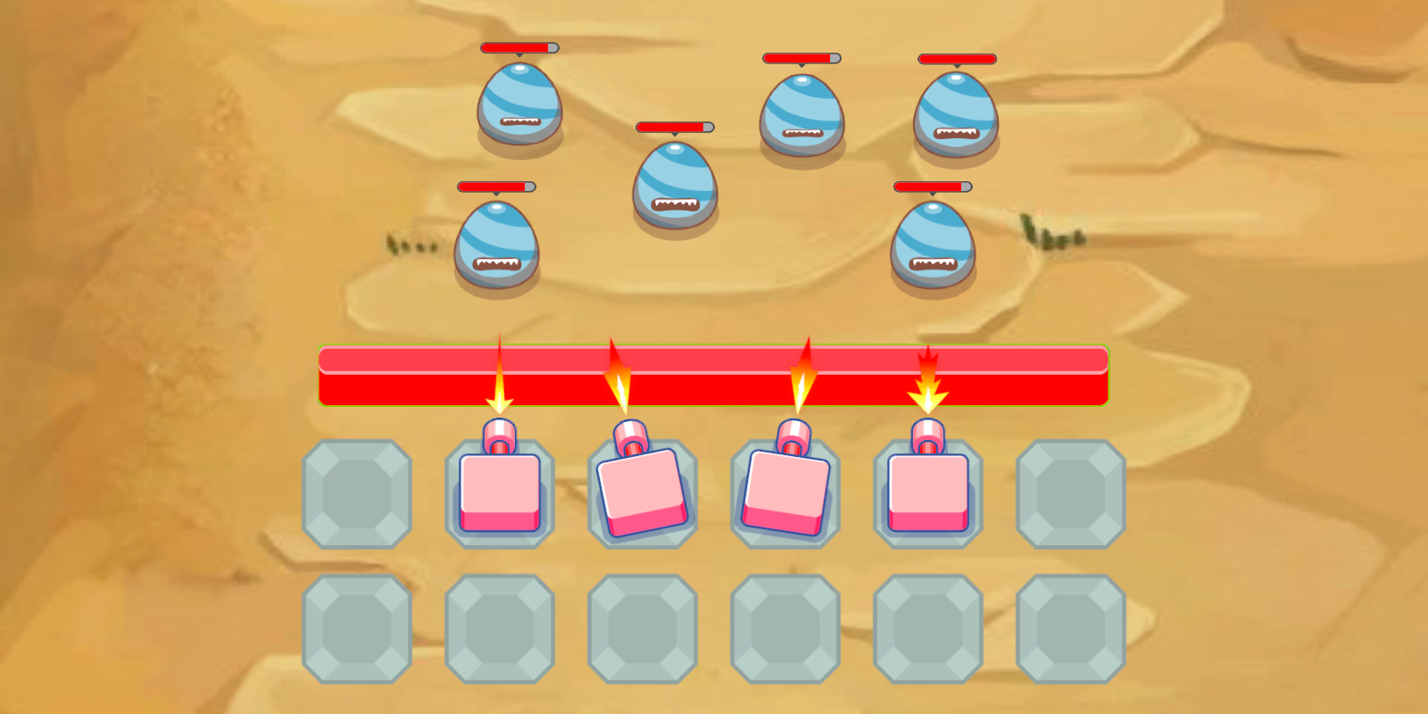

**Monster Defender** is an exciting endless level-base game in which you touch on the screen to move and merge the tanks. The goal is kill all the enemies and bosses to complete the level, collects coins to unlock new cool and powerful tanks. The game is ready to release straight out of the box, and it can also be easily customized to make it even more engaging to your players. Supports for PC/Mac, iOS, Android, etc…!

This template is made with Unity C# and optimized for mobile devices. This template provides you a full-featured, ready-for-release game source code that you can customize and build your own game in no time!

Highlight features:

* Addictive one-touch gameplay
* Smooth control, eye-catching graphics
* 50++ levels (more level will be added soon)
* Very easy to add new levels with detailed instruction
* 20 tank prefabs
* 15 enemy prefabs
* 5 boss prefabs
* Commented C# code with detailed documentation
* Optimized for mobile
* Free-to-use assets (fonts, sounds, music, models, etc.)
* Ready to publish out-of-the-box

# PACKAGES

When you open this template, at first you will some errors in Console window, that’s because this template requires some packages to run. You have to install these packages bellow to have this template run smoothly. Please follow these instructions:

* Open Package Manager by go to Window/Package Manager. If you don’t see Package Manager button, then you have to re-install your unity completely because it’s the problem that Unity Technologies still not able to fix.

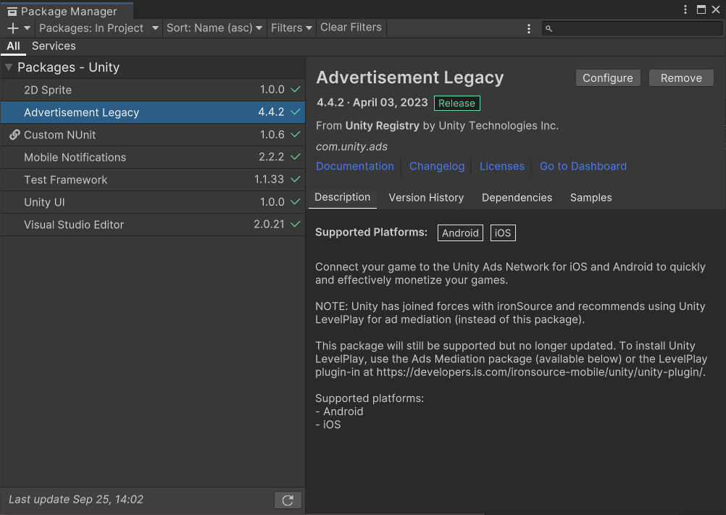

* These are packages you must need to install:
  + Advertisement version 4.4.2 or higher.
  + Mobile Notification version 2.2.2 or higher
  + 2D Sprite version 1.0.0 or higher
  + Unity UI 1.0.0 or higher

# TEMPLATE CUSTOMIZATION

## Ingame Manager

Most of important gameplay parameters can be configured within the IngameManager component which is attached to a game object also named IngameManager in the hierarchy. You can find IngameManager object in Ingame scene.

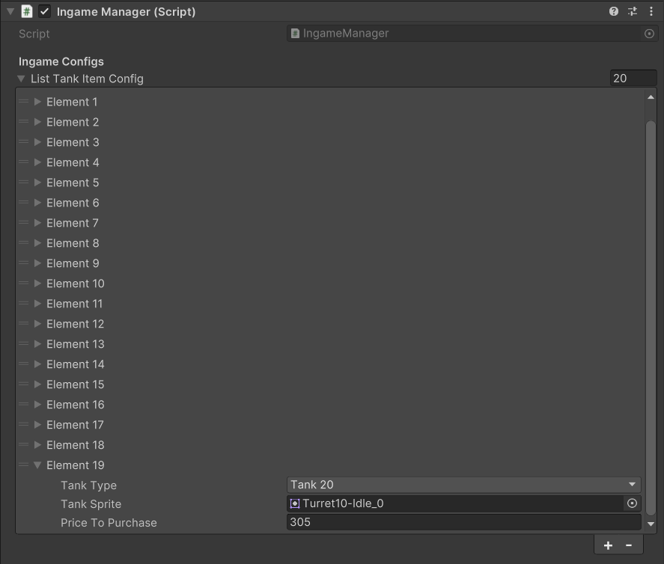

* *Tank Type:* the type of tank that user will unlock.
* *Tank Sprite:* the icon sprite of that tank
* *Price To Purchase:* the price to unlock this tank.

## Tank Controller

Most of important parameters of tank can be configured within the TankController component. You can find all the tank prefabs at Asset/_Monster_Defender/Prefabs/Ingame/Tanks.

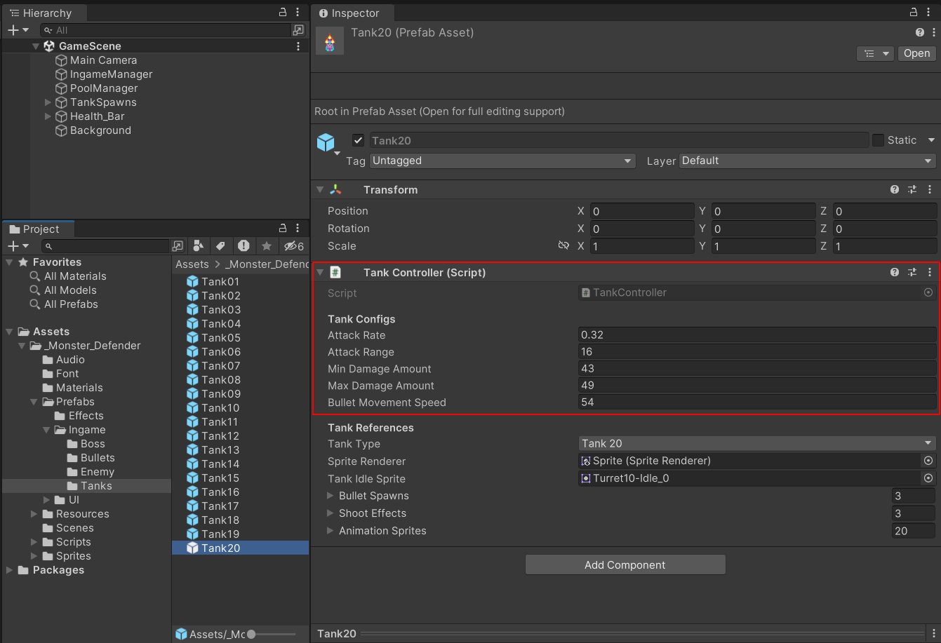

* *Attack Rate:* the attack rate of the tank.
* *Attack Range:* the attack range of the tank.
* *Min Damage Amount:* the minimum damage amount of the tank.
* *Max Damage Amount:* the maximum damage amount of the tank.
* *Bullet Movement Speed:* the movement speed of the bullet of this tank.

## Enemy Controller

Most of important parameters of the enemy can be configured within the EnemyController component. You can find all the tank prefabs at Asset/_Monster_Defender/Prefabs/Ingame/Enemy.

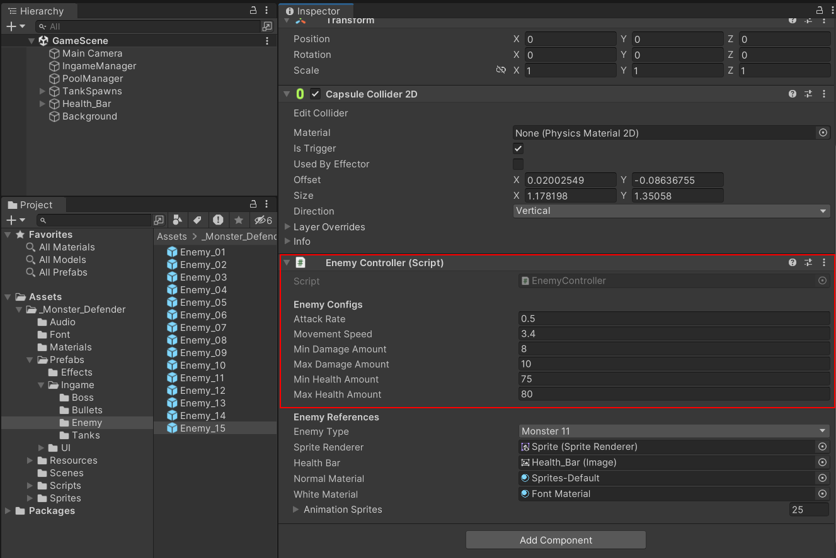

* *Attack Rate:* the attack rate of the enemy.
* *Movement Speed:* the movement speed of this enemy.
* *Min Damage Amount:* the minimum damage amount of this enemy.
* *Max Damage Amount:* the maximum damage amount of this enemy.
* *Min Health Amount:* the minimum health amount of this enemy.
* *Max Health Amount:* the maximum health amount of this enemy.

## Boss Controller

Most of important parameters of the boss can be configured within the BossController component. You can find all the tank prefabs at Asset/_Monster_Defender/Prefabs/Ingame/Boss.

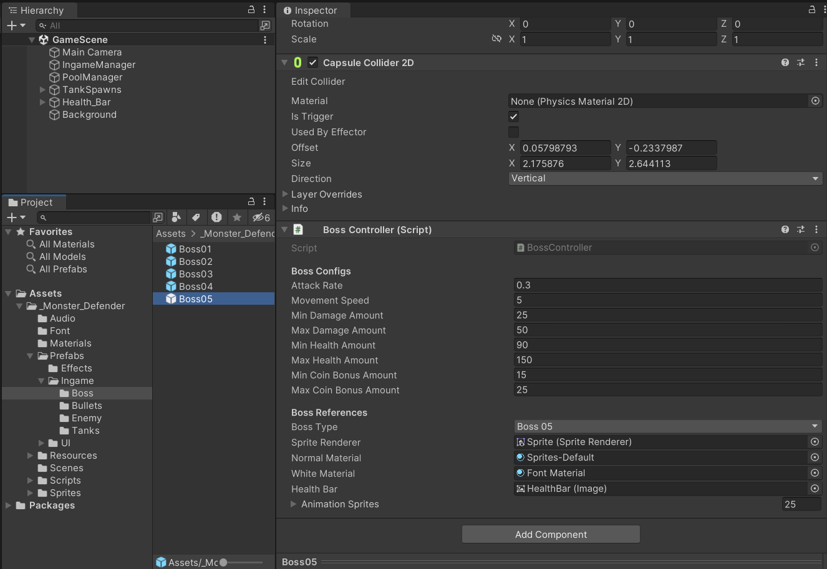

* *Attack Rate:* the attack rate of the boss.
* *Movement Speed:* the movement speed of this boss.
* *Min Damage Amount:* the minimum damage amount of this boss.
* *Max Damage Amount:* the maximum damage amount of this boss.
* *Min Health Amount:* the minimum health amount of this boss.
* *Max Health Amount:* the maximum health amount of this boss.
* *Min Coin Bonus Amount:* the minimum of coin bonus player will get from this boss.
* *Max Coin Bonus Amount:* the maximum of coin bonus player will get from this boss.

## Level Configs

Most of important parameters of the level can be configured within the scriptable object file named LevelConfigSO. You can find all the scriptable object files for level at Asset/_Monster_Defender/Resources/Levels.

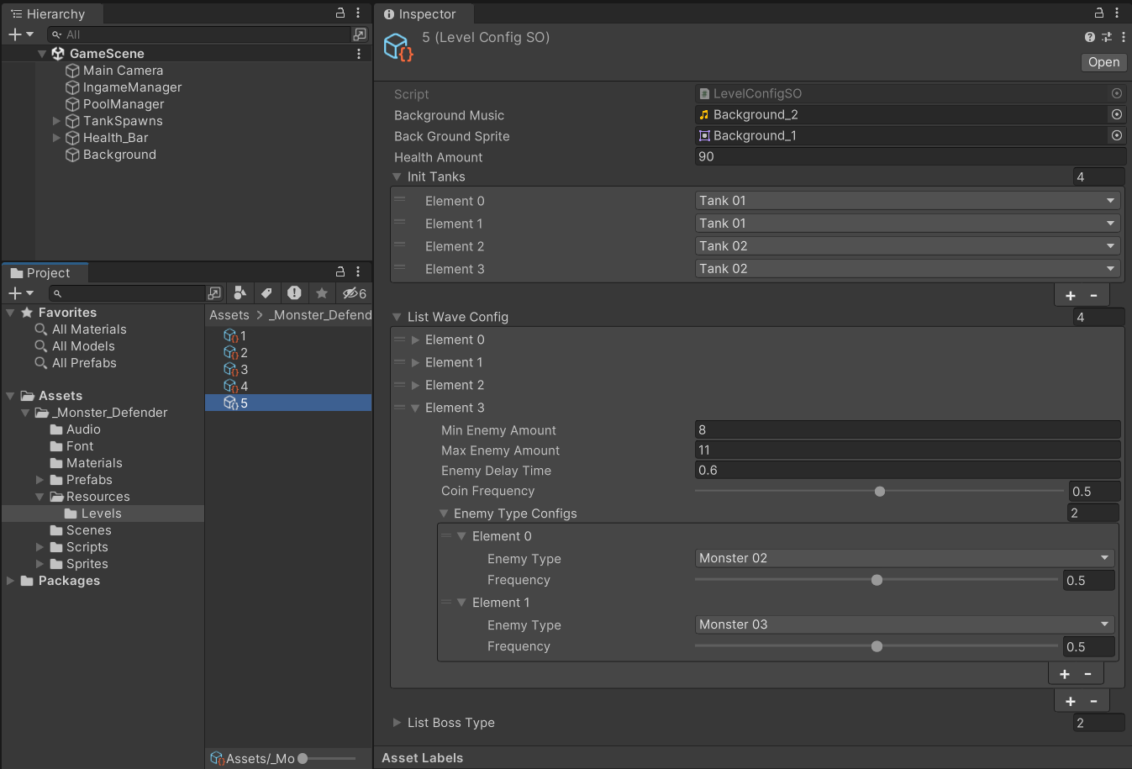

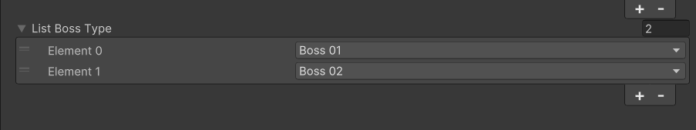

* *Background Music:* the background music of this level.
* *Background Sprite:* the background sprite of this level.
* *Health Amount:* the health amount of this level.
* *Init Tanks:* the list initial tanks when the level started.
* *List Wave Config:* the list wave config of this level.
* *Min Enemy Amount:* the minimum enemy amount of this wave.
* *Max Enemy Amount:* the maximum enemy amount of this wave.
* *Enemy Delay Time:* the delay time to create each enemy.
* *Coin Frequency:* the frequency to create coin after an enemy is destroyed.
* *Enemy Type:* the type of enemy will be created.
* *Frequency:* the frequency to create this type of enemy.
* *List Boss Type:* the list of boss type to create after the waves.